KUPINEČKI DRMEŠI
Jaskansko Prigorje
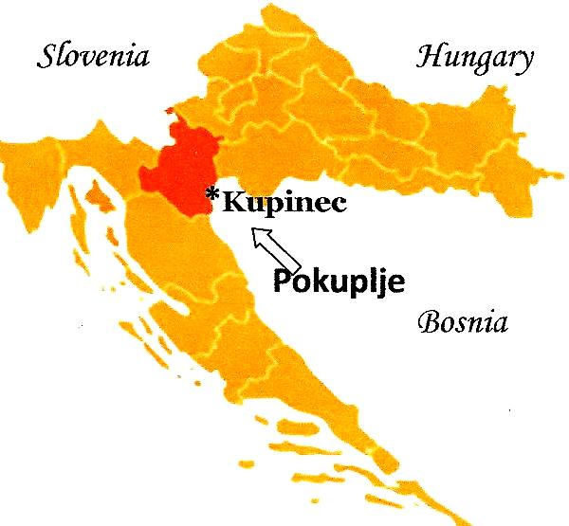
This dance is from the village of Kupinec, which is situated between Zagreb and Karlovac, near Jastrebarsko in the Pokuplje region. The Jastrebarsko dance zone is divided between the Jastrebarsko polje (lowlands) and Prigorje (by the hills). Village of Kupinec is in Jastrebarsko polje. Drmeš (shaking dance) is the most popular dance in this region and is done mostly during holidays and weddings.
The instrumental accompaniment is most often done with two violins, “bugarija” and bass. Here are presented two different drmeš melodies; Pisarov and Cuparov Drmeš.
Željko first researched this region in 1976 and continues to the present days.

TRANSLATION: Shaking dances from the village of Kupinec

PRONUNCIATION Koo-peh-NECH-kee DER-mesh-ee

MUSIC: CD: “Željko Jergan’s Dance Journey” Band 4

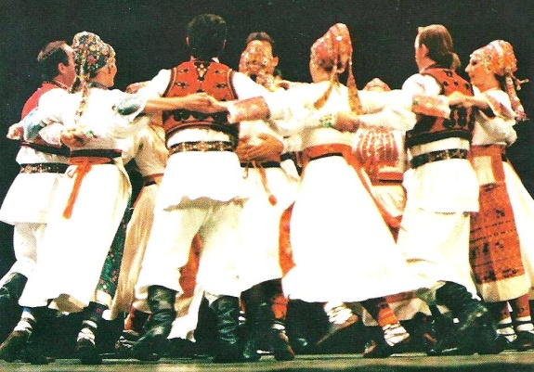
FORMATION: Closed reel (circle) of mixed dancers. An alternative formation is a circle inside a circle and at weddings the bride and groom may be in the center. Hands are joined in a “back hold”, with M’s arms lower and W’s higher, or “back basket hold” L over R.
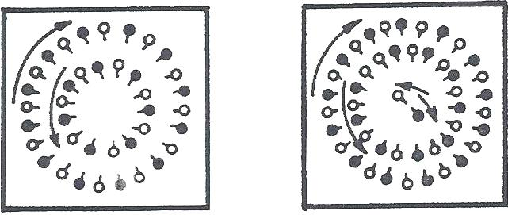

STEPS: Drmeš with Kick: Small step R on R with bent knees, left foot kicks forward (ct 1); closing L to R, bounce twice on both feet - knees flex on each bounce (cts 2,&)
-------------------------------------------------------------------------------------------------------------------------------
METER: 2/4 PATTERN
-------------------------------------------------------------------------------------------------------------------------------
Meas.

Introduction: None

1 First time through first Melody – Music pattern I, II, II

1-8 Part I – No Action

Kupinečki Drmeši, page 2 of 3
Part II A– Circle to the L, CW
1-2 Step on R, swaying twd ctr (ct 1,2), step on L, swaying bkwd outside diag L (ct 1,2).
3-4 Repeat meas 1-2. Small bounce on each count of meas 1-2.
5-8 Facing ctr, 8 walking steps CW, starting on R, one step per ct.
Little accent with hip toward ctr when stepping on R ft.

Part II B – Drmeš with Kick
1-6 6 Drmeš with Kick (cts 1,2,&), always starting with a small step to R on R.
7-8 Stamp three times, R,L,R, hold, no weight on the last stamp.

2 Second time through first Melody – Music pattern I, II, II
Part I – Turns in place
1-2 In place, step on R (ct 1), hop on R (ct 2); step on L (ct 1), hop on L (ct 2).
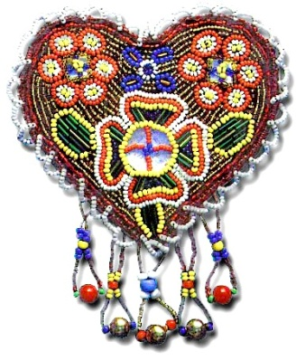
3-4 Turn CW, in place, with 3 steps, R.L.R, hold.
5-8 Repeat meas 1-2 with opp ftwk and direction.

Part II – A & B Circle to the L, CW & Drmeš with Kick
1-8 Repeat 1 Part II A meas 1-8
5-16 Repeat 1 Part II B meas 1-8

3 2nd Melody - Music Pattern I, II, I
Hands in V-pos
Part I – Glide L & Step Hops
1-4 Facing ctr, 4 smooth gliding steps to L, CW, starting on R, one step per ct.
5 Step on R, in place (ct 1), hop on R (ct 2), step on ball of L foot (ct &).
6-8 Repeat three more times (4 total).
9-12 Repeat meas 1-4.
13-16 Repeat meas 5-8, but with circle moving L, CW.

Part II - Reverse Direction
1-2 Swing L foot around, repeat 3 Part I, meas 1-4 with opp ftwk and direction.
3-4 Stamp on L in front of R (ct 1), step on ball of R foot, to R (ct 2). Repeat three more times (4 total).
5-8 Repeat meas 1-4.

Repeat Part I – Glide L & Step Hops
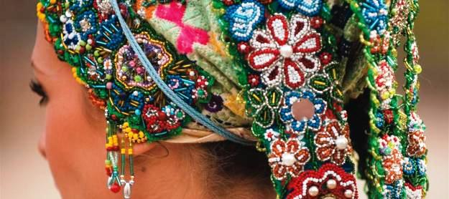
Sequence: 1st Melody Parts I & II
2nd Melody Parts 1, II, I
Spoken: “Mužikaši još jemput!”
(Musicians, one more time!)
Repeat from beg, except no Intro,
start with “Turns in Place” twice.

Dance notes by Željko Jergan and
Cricket Raybern, May 2010

Kupinečki Drmeši, page 3of 3

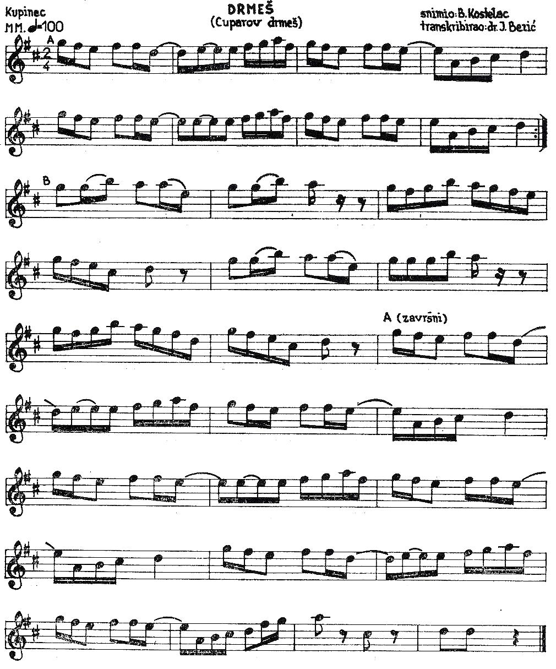
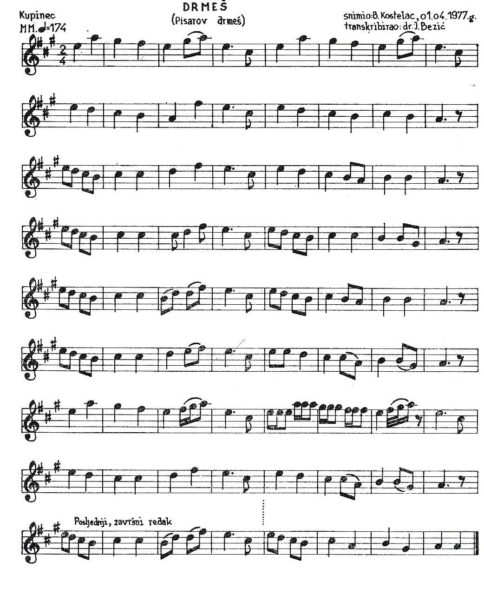
PISAROV DRMEŠ CUPAROV DRMEŠ

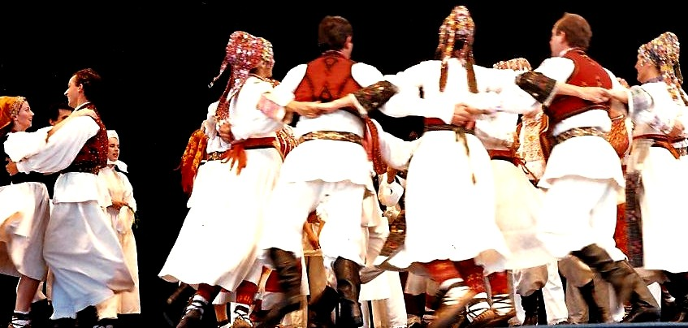

Presented by Željko Jergan

